Github Repo: https://github.com/vida-08/si201-final-project
- The goals for your project including what APIs/websites you planned to work with and what data you planned to gather (5 points)

The goal of this project has been to track relationships between the weather and bird observations, through collecting data from existing databases. The initial API’s we planned on using were eBird, OpenWeather, Openweather's Geocoding, and IsItWater. Through these we planned to gather data of recent bird observations from eBird; then, tag each observation to a place name with Geocoding, as eBird’s location data for observations were in coordinates; then access weather data at each observation’s time and place; and finally determining with IsItWater to see whether or not the observation was over land or over water.

- The goals that were achieved including what APIs/websites you actually worked with and what data you did gather (5 points)

Our initial goals we set out were achieved, although several changes were made to the API’s we used in the end. eBird and Geocoding remained unchanged, however; OpenWeather turned out to require payments for calls, so we replaced it with the open-source Open-Meteo API. We also noticed that all locations of bird observations were already over land, and so IsItWater would not provide any meaningful or useful information, thus, it was replaced with Climate Zone API to obtain the Köppen climate classification for each observation’s location.

- The problems that you faced (5 points)

A main problem in this project was building one clean database from several APIs that all use different formats. eBird gives bird observations with latitude/longitude and a local time string, Open-Meteo works best with Unix timestamps, the geocoding API turns coordinates into place names, and our climate source uses its own Koppen–Geiger zone codes. To connect all of this, we had to convert every time value into Unix time using our convert_time_stamps function, and then store those in a shared timestamps table. We also had to standardize locations into a common structure (standardized name, latitude/longitude, climate zone) and link everything with integer IDs across tables like koeppen_zones, locations, timestamps, bird_observations, and weather_data. On top of that, we needed to handle missing or failed API responses without crashing the program, avoid duplicate rows, and still follow the rule about how many new bird rows we are allowed to insert per run. This required a few rounds of adjusting our schema and cleaning steps until all the joins worked and our final summaries looked correct.

- The calculations from the data in the database (i.e. a screen shot) (5 points) – Mizuki

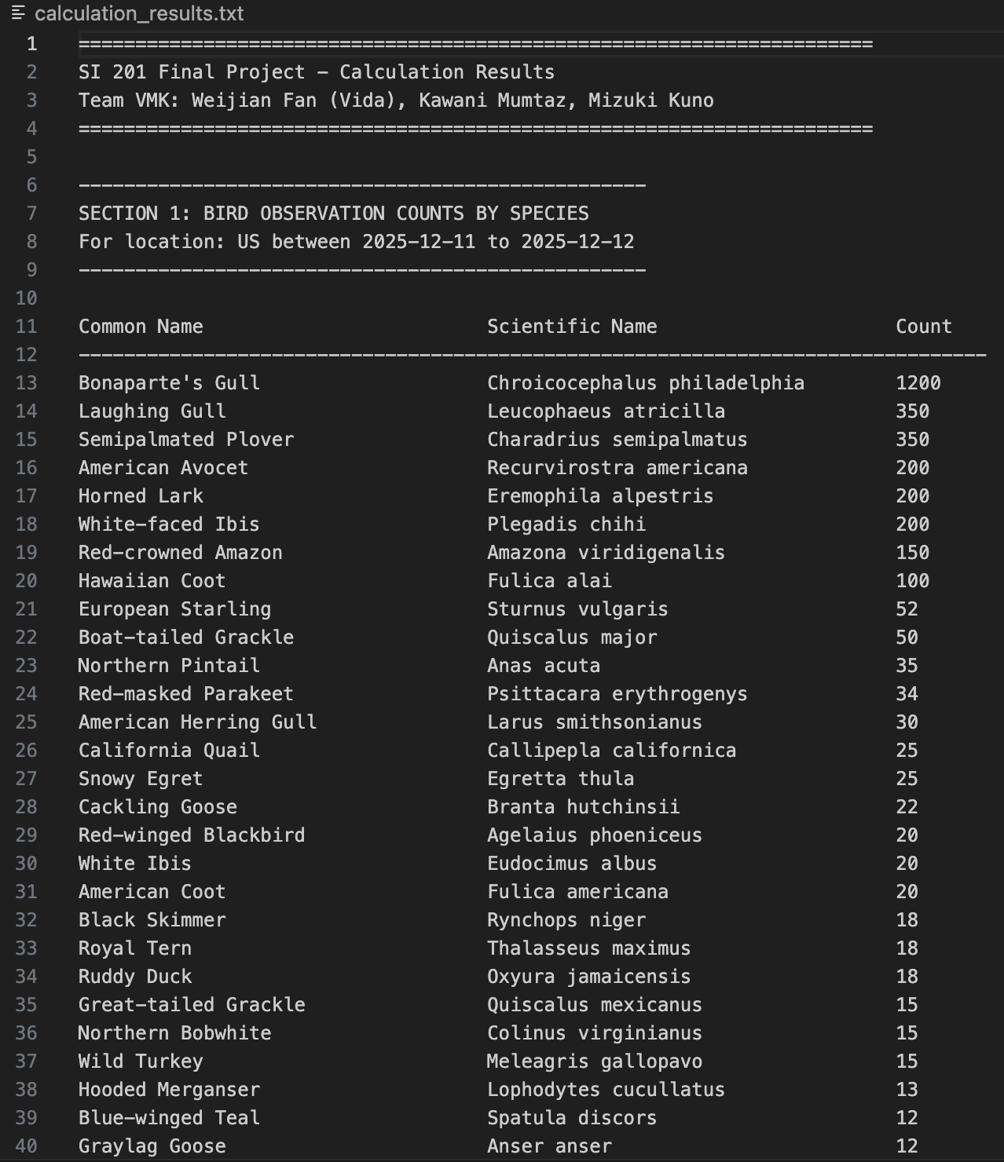
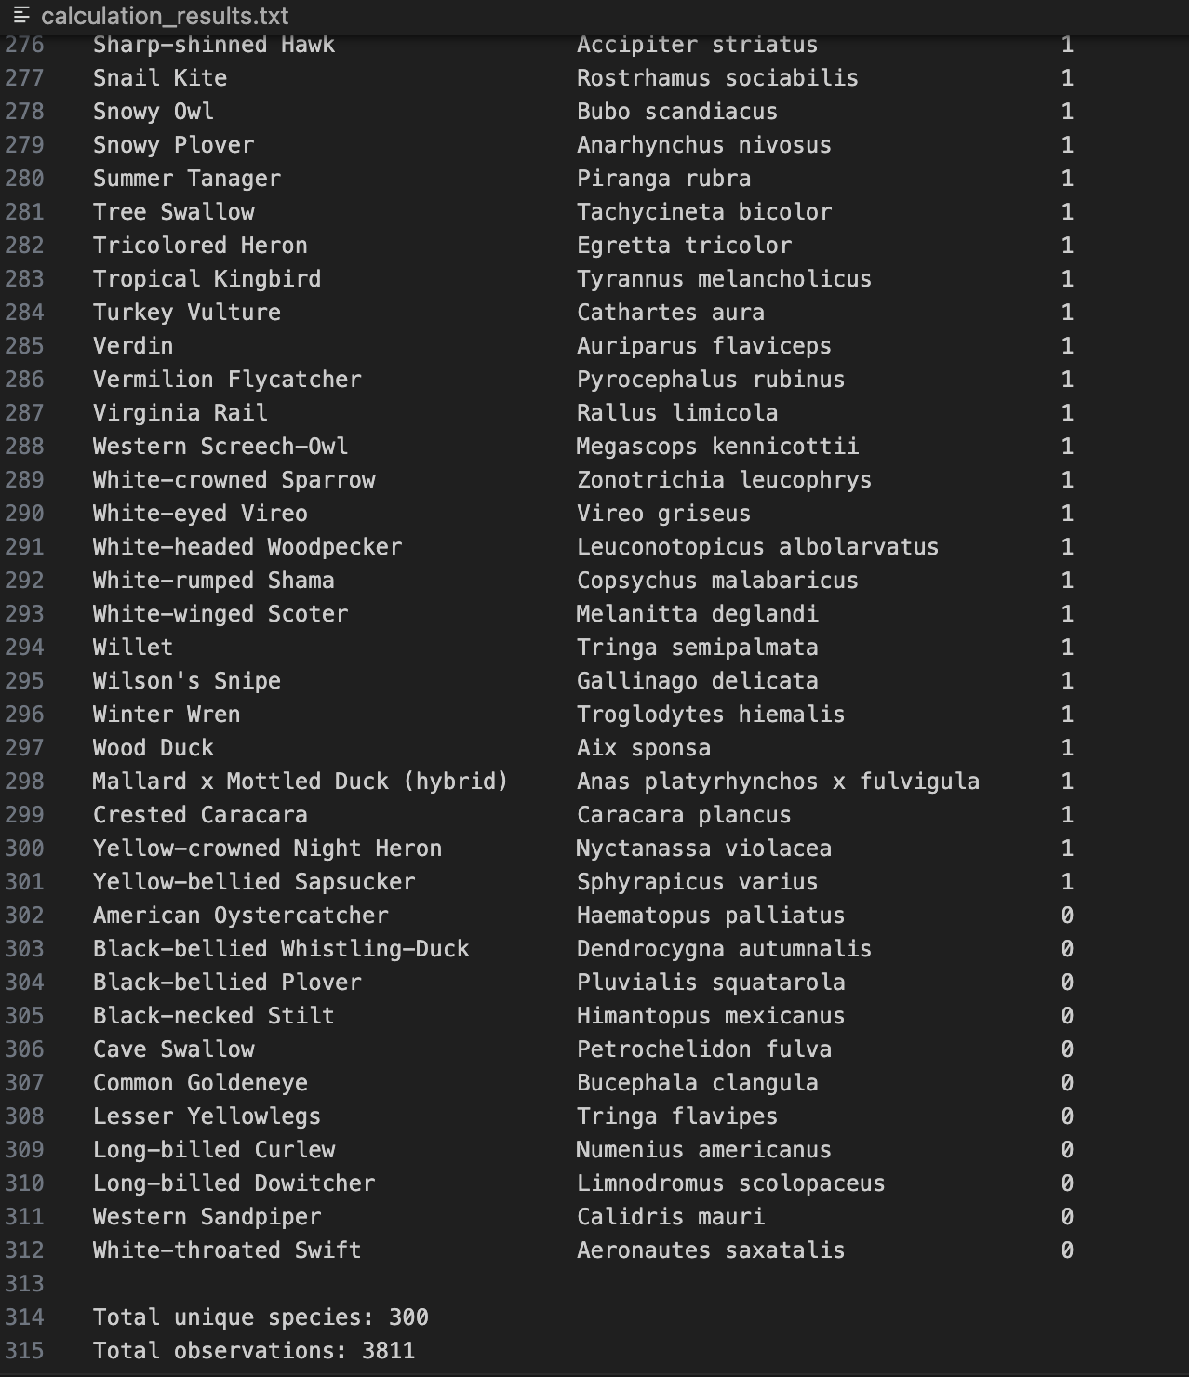
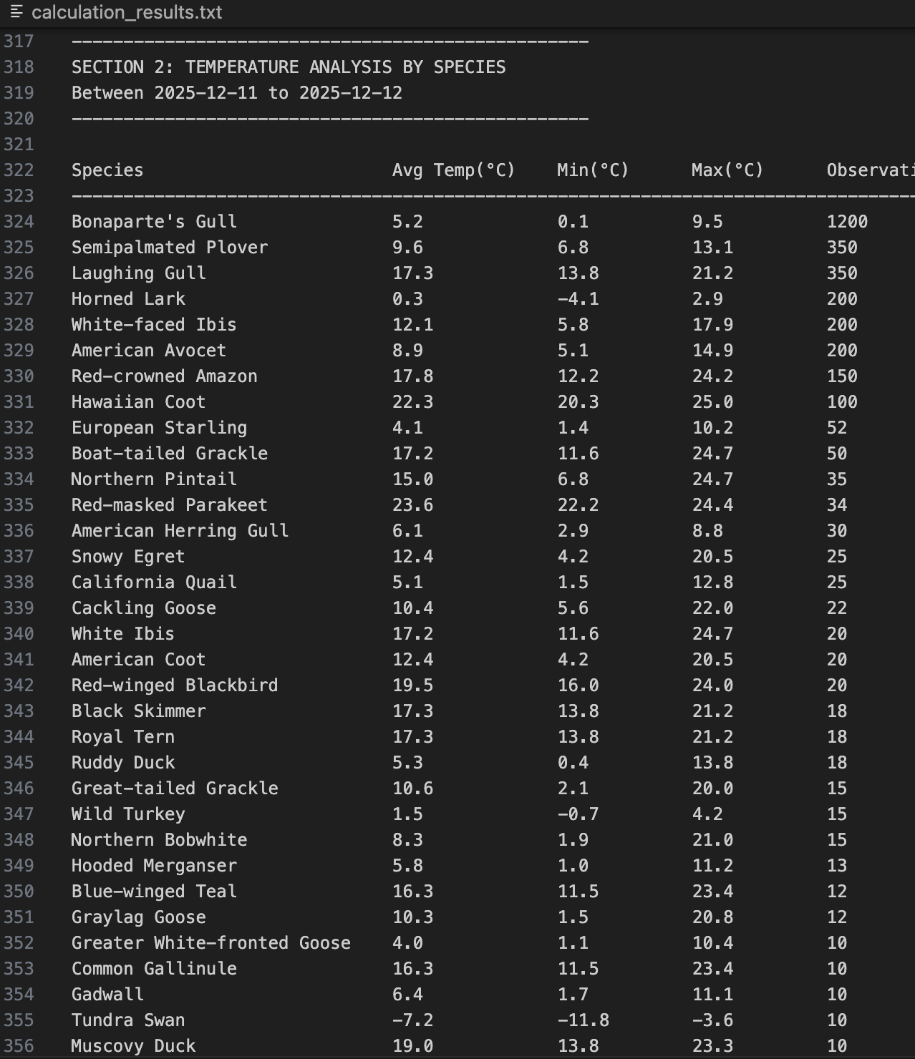
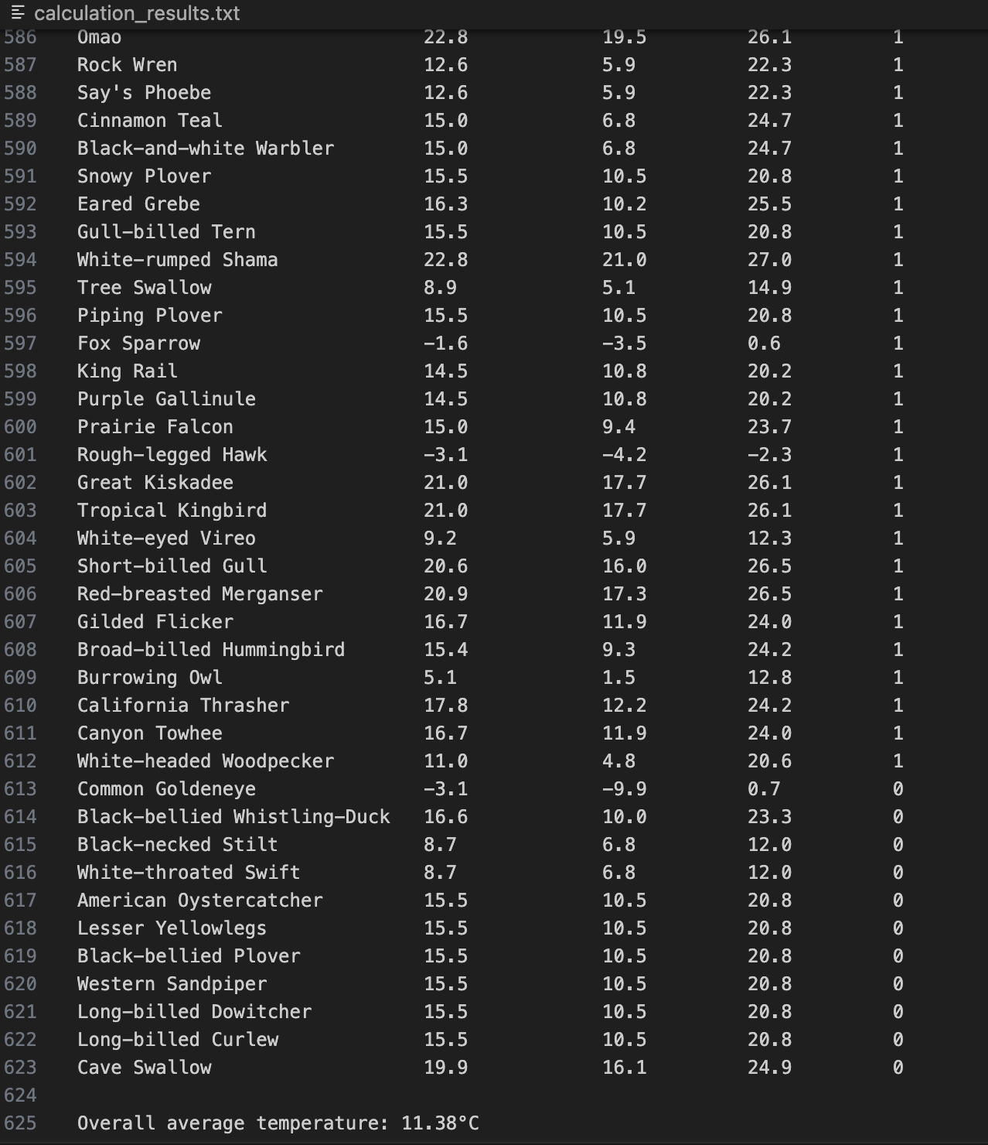
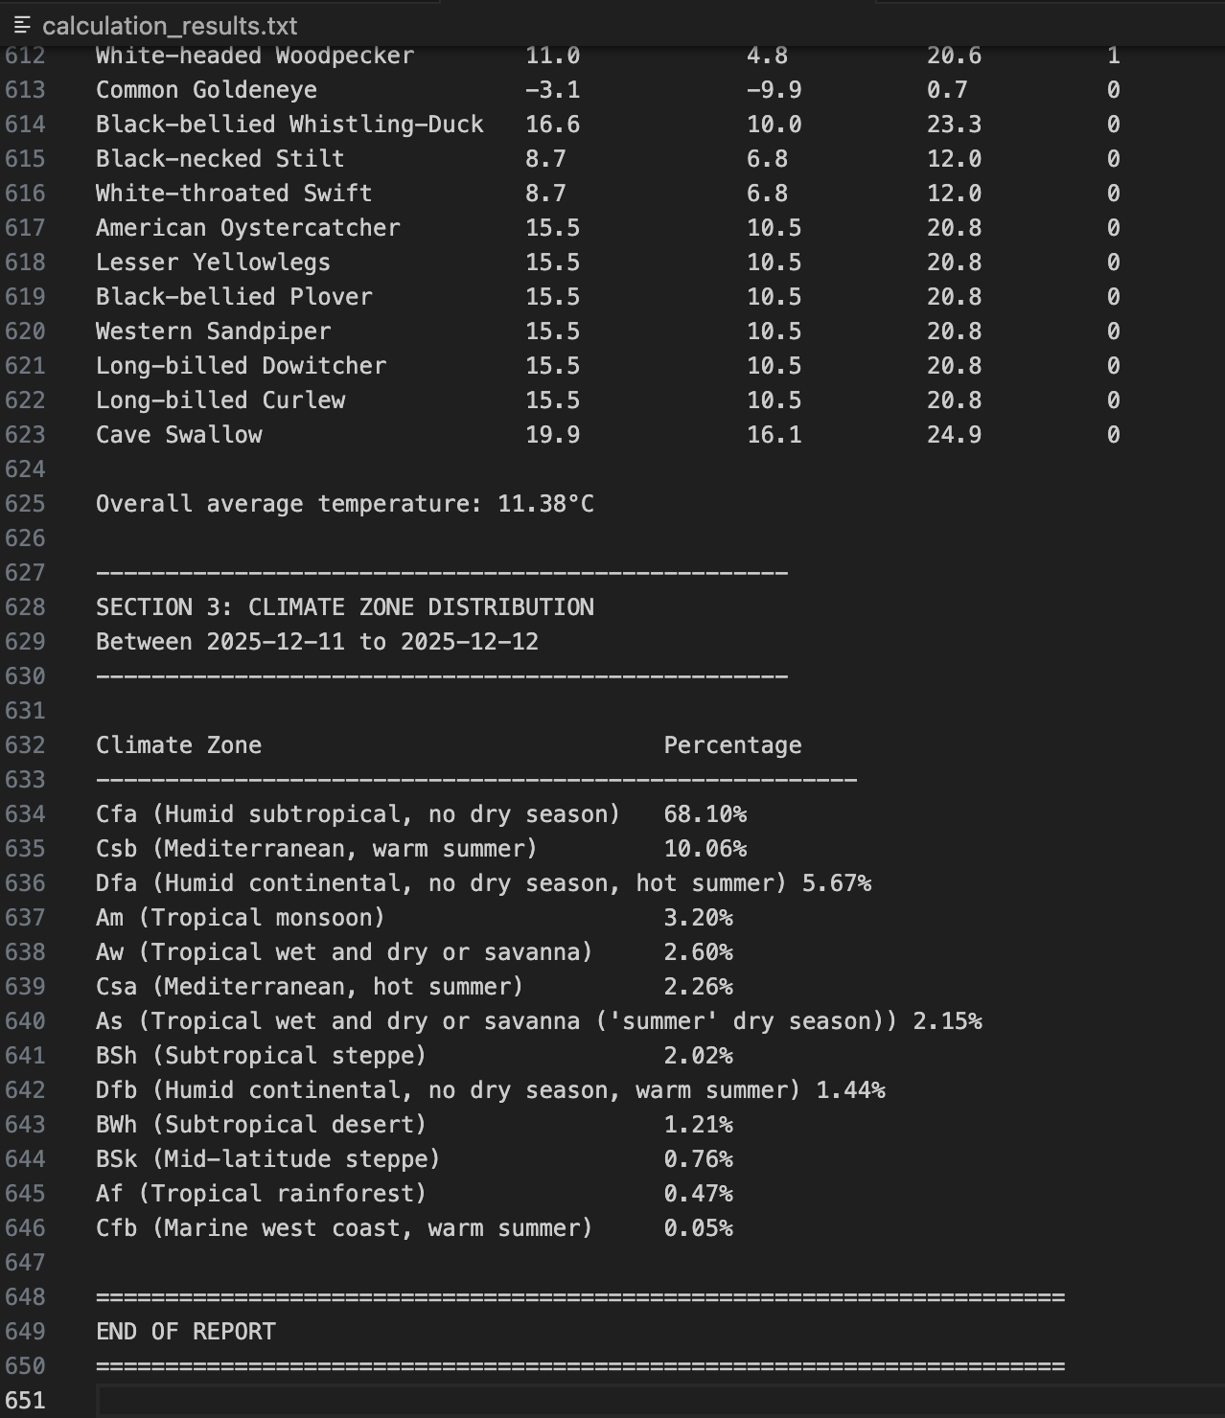

- The visualization that you created (i.e. screen shot or image file) (5 points)
Figure 1: Bird Observation Summary by default location (US)
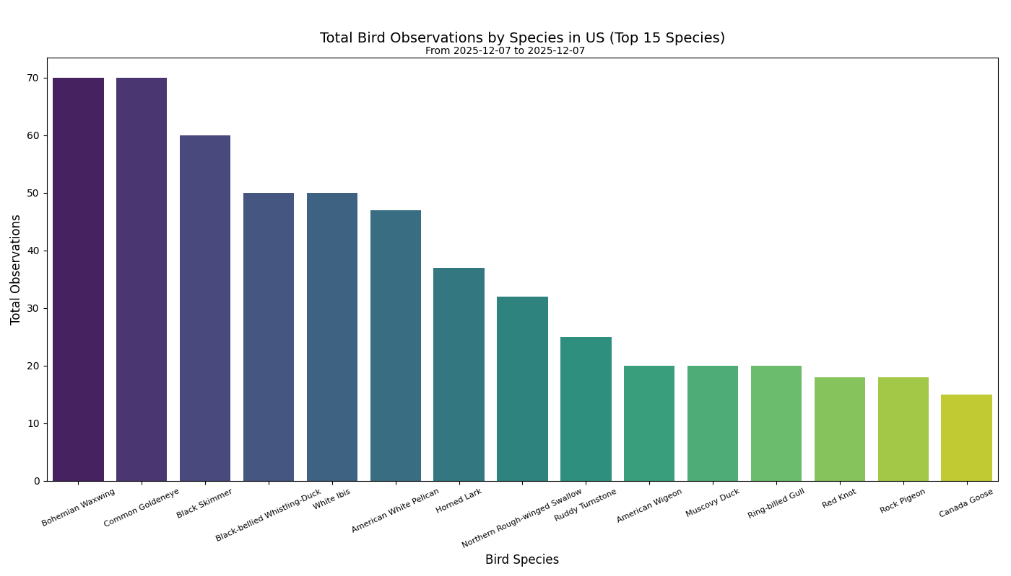

Figure 2: Percentages of Bird Observations by Climate Type
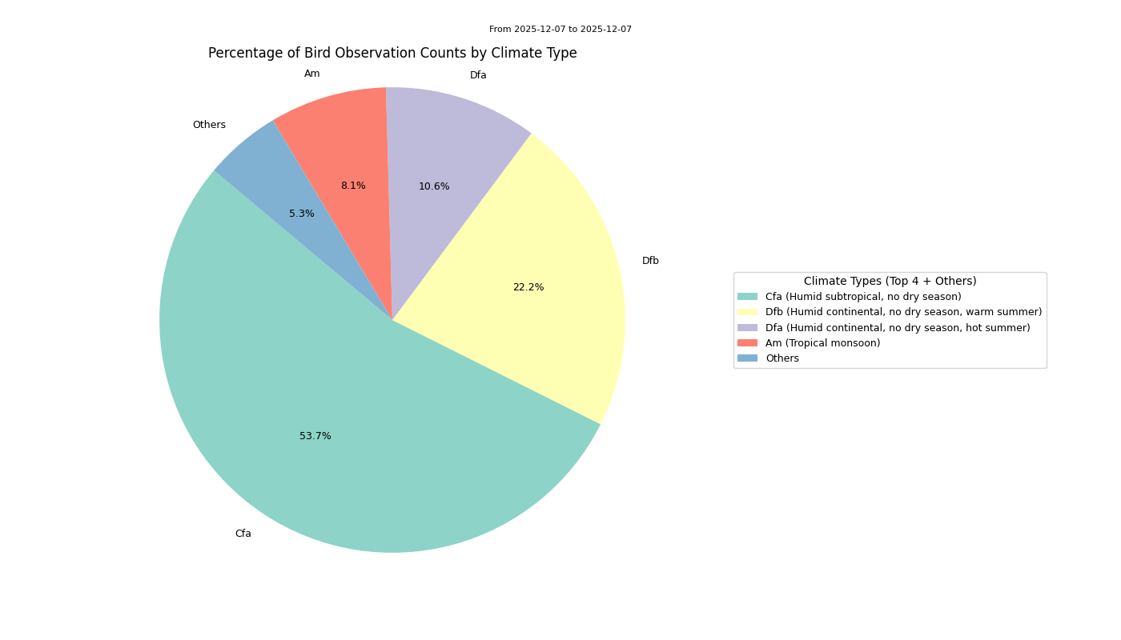

Figure 3: Bird Observation by average temperature
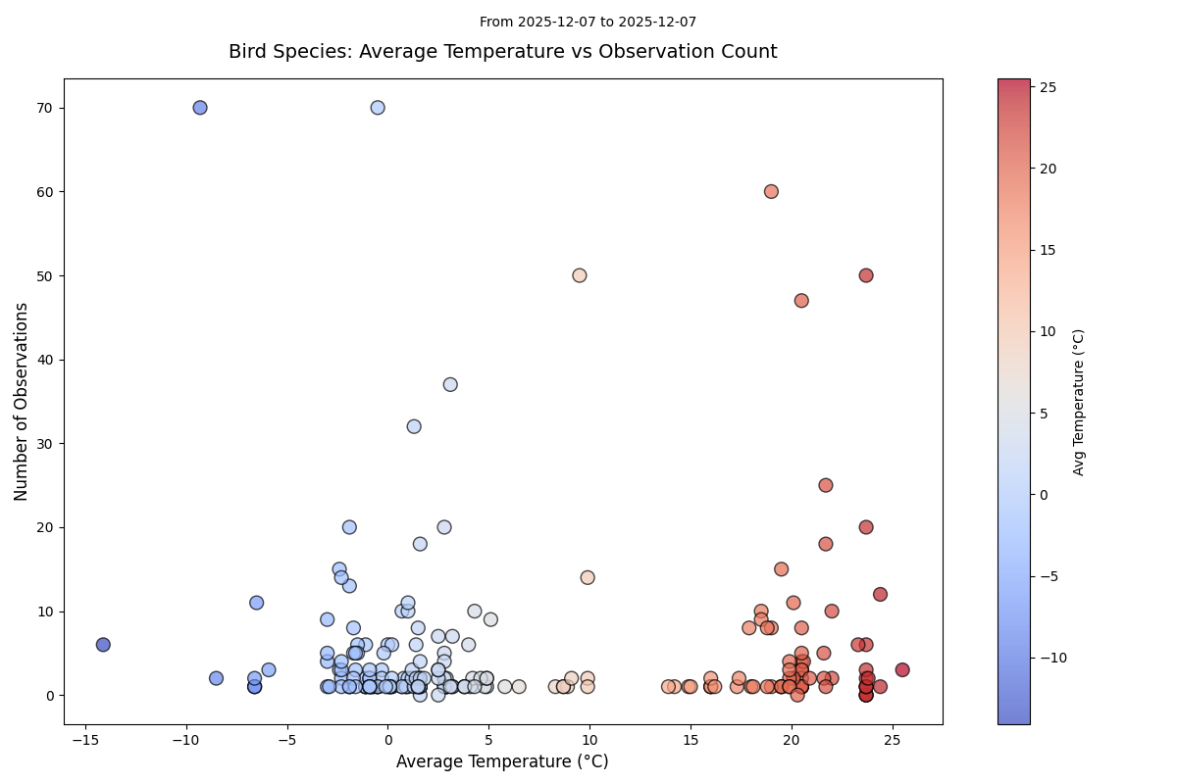

Figure 4: Temperature range at the observation time
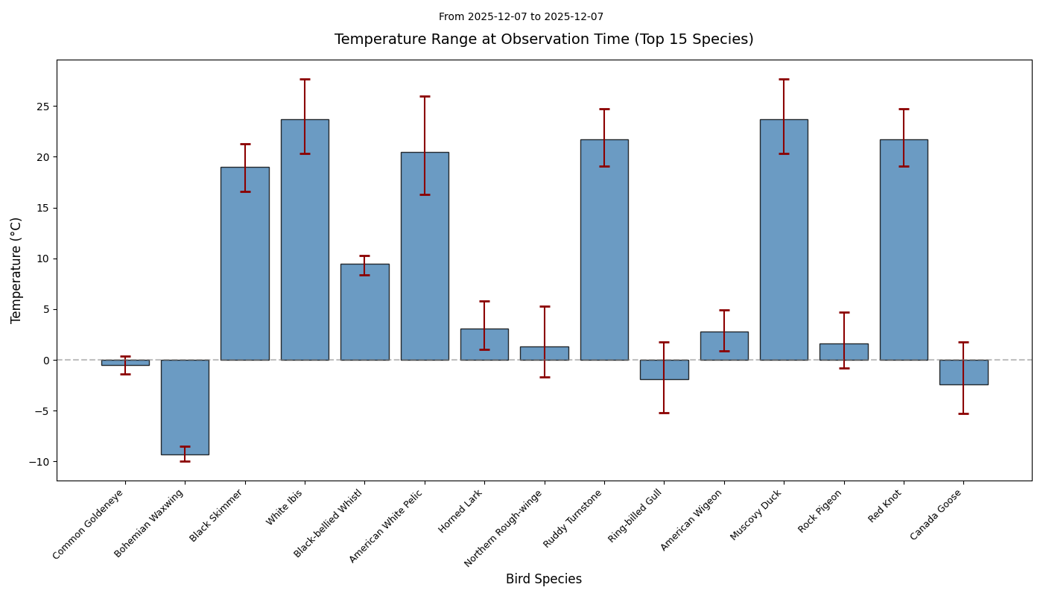

Figure 5: Climate Zone vs. Temperature
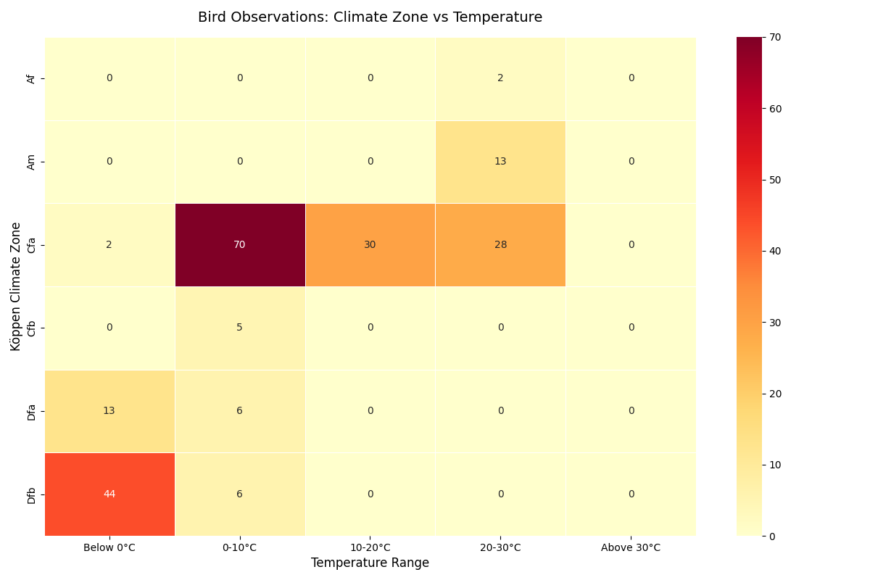

- Instructions for running your code (5 points)
Our project code is in final-project-code.py. It expects Python 3 and these packages: requests, matplotlib, and seaborn (you can install them with pip install requests matplotlib seaborn). In the same folder as the Python file, create a text file named api_keys.txt. Put your keys in it using this format (no quotes, one per line):
BIRD_API_KEY=your_ebird_api_key_here
OPENWEATHER_API_KEY=your_weather_api_key_here (this key is for the Open weather geocoding api, Open-Meteo does not need a key)

Then open a terminal in that folder and run:
python3 final-project-code.py
First, the program asks: “Do you want to update the bird database with new observations? (y/n):” On the first run, type y.
It will then ask: “Enter region code (e.g., 'US', 'CA', 'GB'):”. Type a valid region code (for example, US). If left empty it would go with the default region code ‘US’
Next it’ll ask: “Enter target number of unique locations to load (default 120):”. Enter a number such as 120. The code will call the eBird API, build or update final_project.db, and keep loading data until that many unique locations are stored. Even if the input number is > 25, it will automatically loop and load the data less than 20 per loop. A separate table Koeppen Climate Zone will be built/updated based on the location of the bid observation.

After that, it automatically calls the Open-Meteo API and fills in the weather_data table for all observations.
Once the database is ready (either because you just updated it, or you answered n to skip updating), the program asks for your query:
“Enter location (e.g., 'Ann Arbor, US'):” -> type a place string to match locations in the database.
“Enter bird species common name (e.g., 'Bald Eagle') (enter NONE input for all species):” -> type a specific common name, or type NONE to include all species.

Using this input, the program calculates observation summaries, climate percentages, and historical temperature summaries. It prints results in the terminal, creates several visualizations in Matplotlib windows, and writes a text report called calculation_results.txt in the same folder as final_project.db. If you want to run the unit tests instead of the interactive program, you can comment out the call to main() at the bottom of the file and uncomment the line with unittest.main(verbosity=2), then run the script again.

- An updated function diagram with the names of each function, the input, and output and who was responsible for that function (10 points)
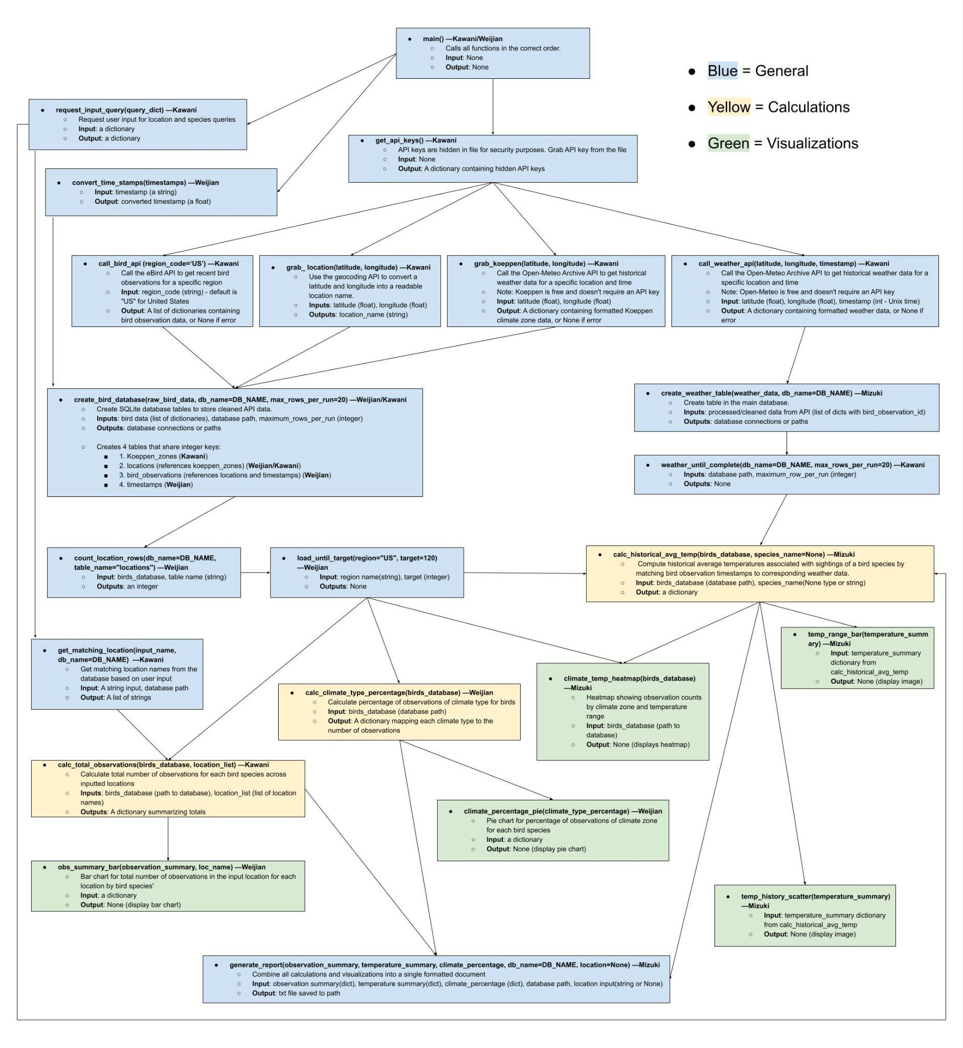

- You must also clearly document all resources you used. The documentation should be of the following form (10 points)

Date | Issue | Description | Location of Resource | Result (did it solve the issue?
Nov 25th | Timestamp conversion | Searched how to convert datetime string to unix time | https://www.geeksforgeeks.org/python/convert-datetime-to-utc-timestamp-in-python/ | Referred to the website and write out the convert_time_stamp function
Nov 26th | API limit | Turns out OpenWeather required payment for weather calls | https://openweathermap.org/api | Switched out to OpenMeteo for weather API
Nov 29th | API Providing No Meaningful Data | All bird observation locations were over land, making the IsItWater API irrelevant, as it would not provide any additional useful information. | http://climateapi.scottpinkelman.com/ | Replaced the API with a climate zone API that provides more detailed classifications and more accurately represents differences in bird distribution.
Nov 30th | Color palette | Confused about the options of color palette to use especially where lots of variables involved | https://seaborn.pydata.org/tutorial/color_palettes.html | Referred to the tutorial for options of color palettes and used the suitable ones
Dec 1st | Scatter Plot | Searched how to make a scatterplot with a colorbar | https://www.youtube.com/watch?v=tmrXuom85TY | After referring to the YouTube tutorial, I checked how to create a scatterplot with a colorbar
Dec 2st | Boxplot | Checked how to make a box plot | https://drzinph.com/how-to-box-plot-with-python/ | Referred to how to make a box plot in bar graph style
Dec 2nd | Heat map | Searched how to make a heat map for our extra credit visualization, since I wasn’t sure the way to make one | https://www.youtube.com/watch?v=0U9cs2V-Mqc | Referred to the YouTube tutorial, the basic idea of how to create a heat map

